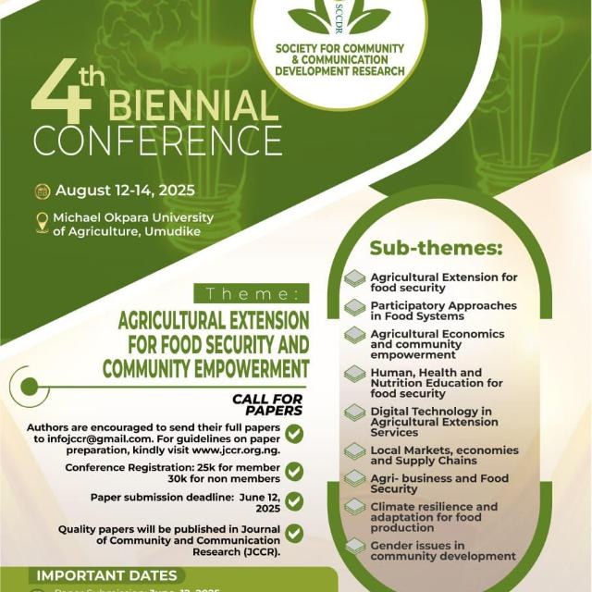

**SOCIETY FOR COMMUNITY AND COMMUNICATION DEVELOPMENT RESEARCH (SCCDR) 2025 CONFERENCE**

**Title: 4th Biennial Conference**

**Theme: Agricultural Extension for Food Security and Community Empowerment**

**Dates: 12TH {opening ceremony}-14TH AUGUST, 2025**

**Venue: Michael Okpara University of Agriculture, Umudike, Abia State, Nigeria. ASUU Secretariat**

**Website:** [**www.jccr.org.ng**](http://www.jccr.org.ng)

**ABOUT THE CONFERENCE**

The 4th Biennial Conference will bring together experts, researchers, and practitioners, to present knowledge and insights on **Agricultural Extension for Food Security and Community Empowerment**. The conference aims to provide a platform for discussion, collaboration, and innovation in the field of focus.

**KEY HIGHLIGHTS**

* **Keynote Speakers: Dr Chibuzor Anyim,** a renowned expert in international private sector extension services.
* **Paper Presentations:** Researchers and practitioners will present their latest findings during the conference.
* **Panel Discussions:** Experts will engage in panel discussions on topical issues
* **Networking Opportunities:** Delegates will have ample opportunities to network with peers and industry leaders

**TARGET AUDIENCE**

**Researchers, Extension and Advisory Services** **Practitioners**, **Industry Leaders**, **Students**.

**CALL FOR PAPERS**

We invite researchers and practitioners to submit their full papers on the topics related to **Agricultural Extension for Food Security and Community Empowerment**.

**Sub-Themes:**

* Agricultural Extension for food security
* Participatory Approaches in Food Systems
* Agricultural Economics and Community Empowerment
* Human, Health and Nutrition Education for Food Security
* Digital Technology in Agricultural Extension Services
* Local Markets, Economies and Supply Chains
* Agri-business and Food Security
* Climate resilience and adaptation for Food Production
* Gender Issues in Community Development

**Paper Submission deadline: July 12 2025**

Papers will be reviewed by a panel of experts, and accepted papers will be presented at the conference.

**NB:** Quality papers will be published in the Journal of Community and Communication Research (JCCR)

PAPER SUBMISSION

Papers should be sent by email to;

**infojccr@gmail.com**

**CONFERENCE REGISTRATION**

Registration is now open for the conference.

**~~N~~25,000 for Members**

**~~N~~30,000 for Non-members**

**Payment:**

**Acct Name: SCCDR**

**Acct Number: 2029371642**

**First Bank**

**CONTACT**

For more information, please contact;

Conference Chairman: Prof. Ike Nwachukwu (+2348035485064)

Conference Administrator: Prof. Jemimah Ekanem (08060790069)

Conference Website – [www.jccr.org.ng](http://www.jccr.org.ng). email, infojccr@gmail.com

We look forward to welcoming you to the 2025 SCCDR **4TH BIENNIAL CONFERENCE**!